Soda Display-4.NBT.5
1. Not counting the extra packs in front of the picture, how many packs make up the Bulls Soda display? How do you know?

2. How much is the Soda display worth (if you’re not sure how much a 12-pack of Coke costs, do a little research or come up with a class estimate)?

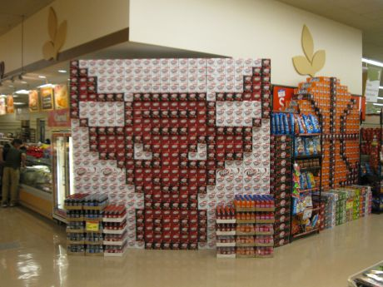

3. If you had all the soda packs you needed, create a soda display of your own (use at least 3 different types of soda). Tell how many packs of each soda you need to create your display. Use the graph paper to show your creation.

4. How much is your soda display worth? What if the store had a buy 2, get 1 free sale?

