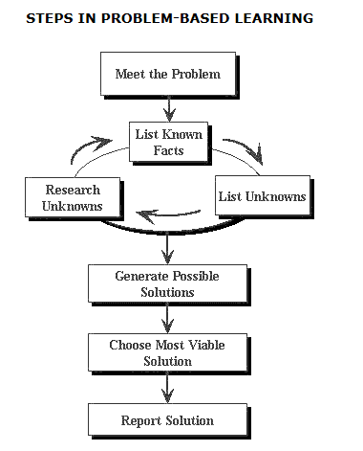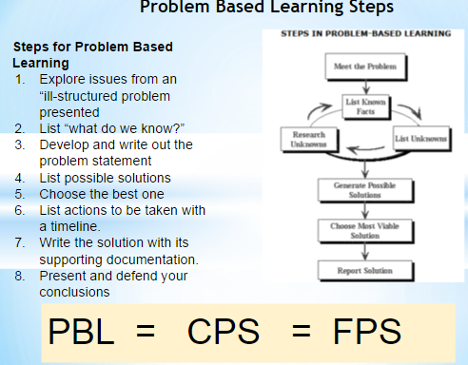

FPS Steps

**1. Identify Challenges**

**2. Select an Underlying Problem**

**3. Produce Solution Ideas**

**4. Generate & Select Criteria to Evaluate Solution Ideas**

**5. Evaluate Solution Ideas**

**6. Develop an Action Plan**